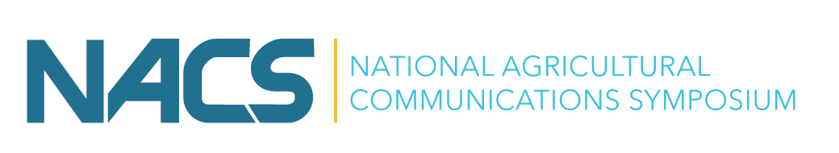

In conjunction with the annual meeting of the
Southern Association of Agricultural Scientists
Feb. 4 - Feb. 9, 2027 (SAAS) | Feb. 7 - 8, 2027 (NACS) Oklahoma City, Oklahoma
2027 NACS Student Scholarship
Deadline: December 11, 2026 by 11:59 pm (Eastern Time)
The National Agricultural Communications Symposium (NACS) will meet Feb. 7-8, 2027, in Oklahoma City, Oklahoma. The full SAAS conference meets February 4 to February 9, 2027.

The NACS $100 Student Scholarship is designed to support undergraduate and graduate students pursuing interests in agricultural communications. The scholarship provides students with an opportunity to engage with professionals, researchers, educators, and fellow students from across the country while gaining exposure to current issues, trends, and career opportunities within the field.

Student recipients will be selected based on their demonstrated interest in agricultural communications, potential for professional growth, and the anticipated impact conference participation will have on their academic and career goals.

ELIGIBILITY
Applicants must:
- Be enrolled as a full-time undergraduate or graduate student at the time of application; proof of full-time enrollment may be requested.
- Attend the 2027 National Agricultural Communications Symposium.
- Applications that are incomplete, submitted after the deadline, or do not follow the application guidelines will not be considered for funding.
APPLICATION INSTRUCTIONS
- Responses should be limited to 250 words or fewer per question unless otherwise specified.
- Applicants should use the dedicated application template to prepare their responses.
- Completed applications must be submitted as a one PDF document.
- Please save the file using the following name: lastname_NACSscholarship.pdf.

QUESTIONS
- Describe your involvement and experience in agricultural communications. This may include coursework, student organizations, internships, employment, research, leadership positions, or other relevant experiences.
- What are your career aspirations and how do you see agricultural communications contributing to your future professional goals?
- How will attending the National Agricultural Communications Symposium contribute to your academic, professional, and personal development?
- What expenses do you anticipate incurring while attending the National Agricultural Communications Symposium? Please identify any additional sources of financial support you expect to receive (from your institution, advisor, etc.).
- Have you previously attended the National Agricultural Communications Symposium? If yes, please indicate the year(s) attended and briefly describe how the experience benefited you.
APPLICATION SUBMISSION AND REVIEW
Applications will be reviewed by the Scholarship Chair and Co-Chair.

Please use the dedicated template and submit a PDF of your application via this Google Form:
NACS Student Scholarship Application Link [CLICK HERE]

Applications should be formatted and submitted as a PDF. All applications should be submitted using the link above. Submitting applicants will be asked to provide the following information:
- Email
- Institution Name
- Department Name
- Degree Program

Please contact Ms. Kenna Sandberg (ksandbrg@calpoly.edu) if you have questions about the submission. Please copy Dr. Carrie Baker (carrie.n.baker@okstate.edu) to ensure all emails are received and reviewed. For more information about the NACS meeting, please visit https://www.nacsweb.org/.

Scholarship recipients will be notified by January 4, 2027.

